**Annual Report of Patuakhali Govt. College for the year 2023**

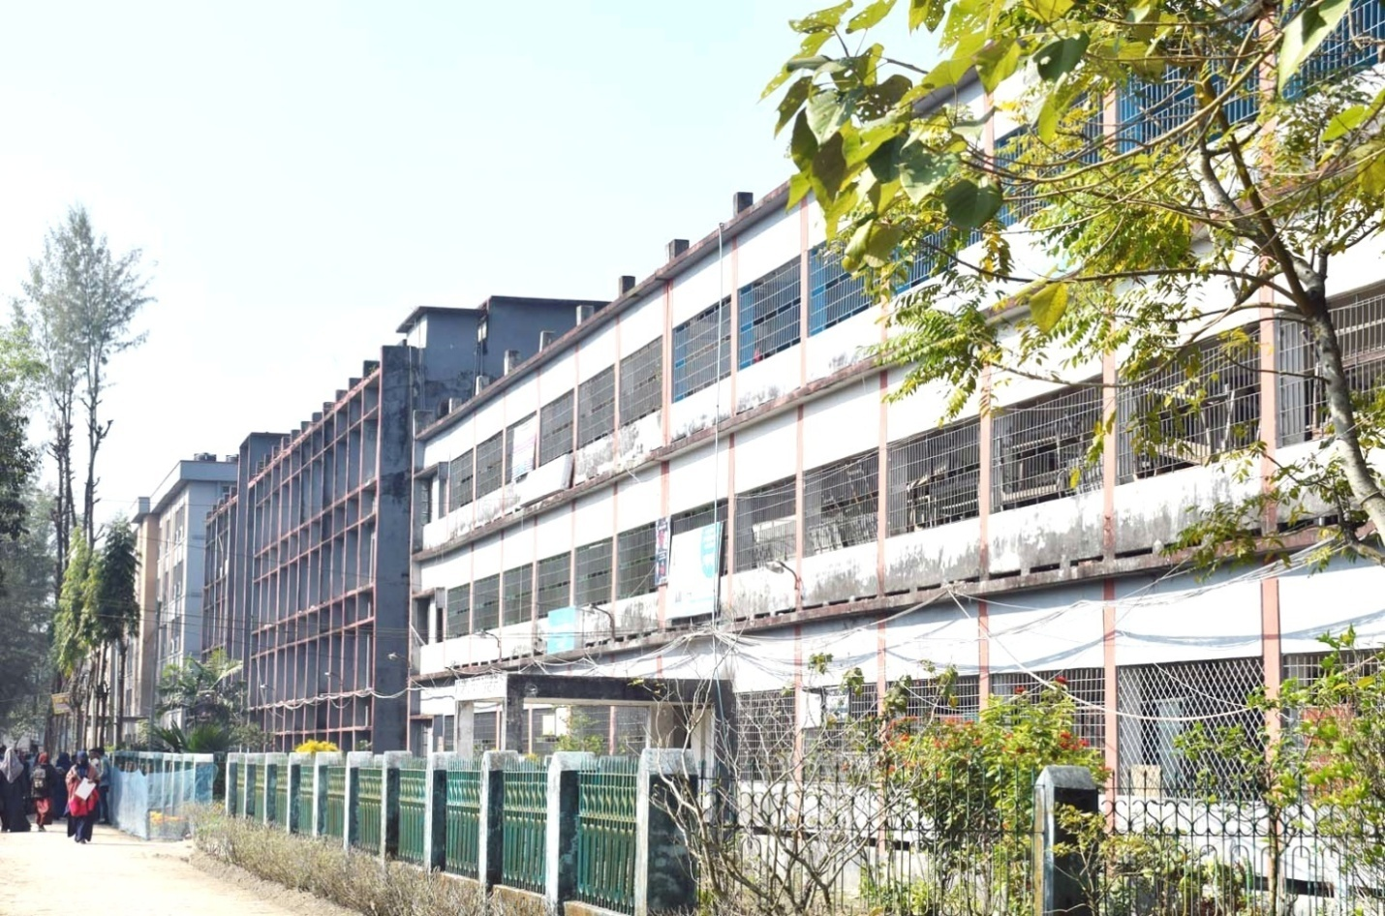

**ANNUAL REPORT 2023-24**



**Patuakhali Govt. College**

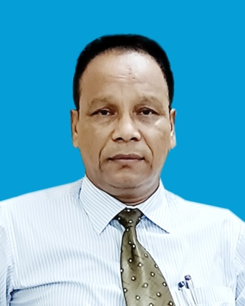

**Professor Md. Nurul Amin**

**Principal & IDG Manager**

**PatuakhaliGovt College, Patuakhali**

**Message**

To Improve the Human Resources of the country, the College Education Development Project (CEDP) was incepted in 2016. The CEDP aims to strengthen the strategic planning and management capacity of the college education subsector and to improve the teaching and learning environment of participating colleges.The Project specifically focuses on the tertiary college education sector under the National University (NU)in Bangladesh.

I think this report will help to facilitate effective decision making or action or to support future planning. Itallowsinformation, ideas whatever wehave done by using the IDG fund.

**INDEX**

|  |  |  |
| --- | --- | --- |
| **Chapter** | **Contents** | **Page** |
| **Chapter-1** | **INTRODUCTION** | **5** |
| **Chapter-2** | **Overview of the College (Institutional and Academic)** | **7** |
| **Governance and Teaching Structure** | **8** |
| **List of Departments and others Academic Programs** | **9** |
| **Key Academic Statistics** | **10** |
| **Infrastructure and Facility Profile of the College** | **11** |
| **Chapter-3** | **Highlights of the Year** | **13** |
| **Key Achievements and Highlights of the Year of the College** | **14** |
| **Key Achievements and Highlights of the Year of the Departments** | **15** |
| **Highlights of Student Activities of the Year** | **15** |
| **Key Achievements and Highlights of the Year of Institutional Development Grants (IDG) 11** | **16** |
| **Chapter-4** | **Teacher Development** | **17** |
| **Overview of Teaching Force of the College** | **18** |
| **Teacher Professional Development Programs** | **19** |
| **Highlights of Teacher Development Activities of the Year** | **20** |
| **Chapter-5** | **Budget and Finance** | **21** |
| **Summary of Annual Budget and Expenditures**  **Summary of Annual Revenues** | **23** |
| **Chapter-6** | **Concluding Remarks** | **24** |
| **Overall Assessment of Performance of the Last year and Key Target for the Next Year** | **24** |
| **Key Challenges and Risks for the College** | **25** |
| **Recommendations** | **26** |
| **Chapter-7** | **Photo Gallery** | **27** |

**Chapter – 1 Introduction**

Patuakhali Govt. College was established in 5th June 1957. It is the second Largest College in Barishal division. There are more than 15000 students in this college. It is situated in PatuakhaliSadar, Patukhali. This college serves all types of communities like service man, Businessman, farmers etc. The devotion of the competent Principles and teachers has contributed much to the earning of much reputation and enrichment of the institution at present time. The college is running successfully its academic activities including Science, Business Studies and Humanities group at HSC level; BA, BSS, BBS, BSC Bachelor Degree (Pass) courses, Honors’ and masters course in Bangla, English, Islamic History, Political Science, History, Soil Science, Physics, chemistry, zoology, botany, Islamic studies, Economics, Accounting, Management, Mathematics, The running Principal & Vice Principal with their heartiest cordiality have turned the college into a sanctuary for the meritorious students. The college campus has been gorgeously decorated with many of its rebuilding and infrastructural development initiatives. The authority has continued its endeavor to establish a multipurpose building. The institution is recognized as the best for education under BarisalEducation Board in respect of passing rate & obtaining GPA 5. Every year the students of this college take place in reputed public & private universities, medical colleges as well. With regard to securing first class in Honors & Masters, its success in noteworthy. Besides, the college offers various scholarships including it are furnished with a rich library, post office, auditorium, pond, playground, scenic boundary wall, garden and a mosque. Total area of this college is 21 acre. Moreover, BNCC & Rover Scout, Red Crescent is very active in the campus .The number of participants in many literary & cultural activities are higher than that of any other institution of the city. The students of this college actively take part in many national level competitions and earn distinction every year. It is worth mentioning that many former & present students of the college have kept themselves engaged in many humanitarian activities upholding the spirit of our liberation war.

**Chapter -2: Overview of the College (Institutional and Academic)**

**2.1 Governance and Teaching Structure**

There are a Principal, a Vice Principal, 04 Professor, 19 Associate Professors, 24 Assistant Professors, 13 Lecturers and 00 Demonstrators’ posts in the teaching structure of this college.There are 26 office staffs for running the office of the college smoothly. The department wise lists of the teaching staffs and office staffs are given below.

**Department wise Teaching Staffs**

|  |  |  |  |  |  |  |  |  |
| --- | --- | --- | --- | --- | --- | --- | --- | --- |
| **Serial No.** | **Name of Department** | | **Professor** | **Associate Professor** | **Assistant Professor** | | **Lecturer** | **Demonstrator** |
| 1 | Bangla | | 01 | 01 | 05 | | 00 | - 7 |
| 2 | English | | - | 01 | 01 | | 02 | - 4 |
| 3 | Political Science | | 00 | 02 | 02 | | 02 | - 6 |
| 4 | Economics | | 01 | 02 | 02 | | 00 | - 5 |
| 5 | Zoology | | - | 01 | 01 | | 00 | - 2 |
| 6 | History | | - | 01 | 01 | | 01 | - 3 |
| 7 | Islamic History | |  |  | 01 | | 02 | - 3 |
| 8 | Philosophy | |  | 02 | 01 | | 00 | - 3 |
| 9 | Islamic Studies | | - | 01 | 02 | | 02 | - |
| 10 | Accounting | | 01 | 02 | 01 | | 00 | - |
| 11 | Management | | - | 01 | 02 | | 00 | - |
| 12 | Physics | | 01 | 01 | 01 | | 00 | 00 |
| 13 | Chemistry | | - | 01 | 01 | | 01 | 00 |
| 14 | Botany | | - | 01 | 01 | | 02 | 00 |
| 15 | Soil Science | | - | 00 | 00` | | 00 | 00 |
| 16 | Mathematics | |  | 02 | 02 | | 00 | - |
| 17 | ICT | | - | - | - | | 01 | - |
|  |  | |  |  |  | |  |  |
| Total | | 04 | | 19 | | 24 | 13 | 00 |

**Other Staffs**

|  |  |  |  |
| --- | --- | --- | --- |
| **Serial No.** | **Name of the Post** | | **No. of Posts** |
| 1 | Librarian | | 01 |
| 2 | Assistant Librarian | | - |
| 3 | Physical Trainer | | - |
| 4 | Head Assistant | | 01 |
| 5 | Accountant | | 01 |
| 6 | Cashier | | 01 |
| 7 | Account Assistant | | 02 |
| 8 | Office Assistant cum Typist | | 04 |
| 9 | Mechanic cum Electrician | | - |
| 10 | Store Keeper | | 01 |
| 11 | Expert Bearer | | 02 |
| 12 | Book Sorter | | - |
| 13 | Cash Pion | | - |
| 14 | Office Assistant | | 12 |
| 15 | Sweeper | | 01 |
| Total | | 26 | |

**2.2 List of Departments and others Academic Programs**

There are 17 departments in this college. In the academic year 2023-24, a total no of 4700 students were admitted in Honor’s and Masters Levels. Besides this, 539 students were also admitted in Degree (Pass) course. Furthermore about 650 students are selected for the admission in the HSC level. Lists of the department wise enrolled students and the teachers teaching in the departments are given bellow

**No. of Students Enrolled in Honors & Masters Courses:**

|  |  |  |  |  |  |
| --- | --- | --- | --- | --- | --- |
| ***Serial No.*** | ***Department*** | | ***Honors***  ***(2023-24)*** | ***Masters***  ***Part-I***  ***(2020-2021)*** | ***Masters Final***  ***Part***  ***(2021-2022)*** |
| *1* | *Bangla* | | *120* | *N/A* | *73* |
| *2* | *English* | | *120* | *N/A* | *49* |
| *3* | *Political Science* | | *170* | *143* | *141* |
| *4* | *Economics* | | *120* | *07* | *47* |
| *5* | *History* | | *105* | *28* | *45* |
| *6* | *Islamic History* | | *160* | *48* | *88* |
| *7* | *Philosophy* | | *95* | *02* | *20* |
| *8* | *Islamic Studies* | | *90* | *33* | *32* |
| *9* | *Accounting* | | *200* | *12* | *130* |
| *10* | *Management* | | *170* | *37* | *111* |
| *11* | *Physics* | | *50* | *N/A* | *N/A* |
| *12* | *Chemistry* | | *60* | *04* | *46* |
| *13* | *Botany* | | *80* | *24* | *32* |
| *14* | *Mathematics* | | *80* | *30* | *67* |
| *15* | *Zoology* | | *70* | *14* | *30* |
| *16* | *Soil Science* | | *60* | *03* | *45* |
| *17* | *ICT* | | *N/A* | *N/A* | *N/A* |
| *Total* |  | *1750* | | *385* | *956* |

**No. of Student Enrolled in Degree Courses (2023-24)**

|  |  |  |  |
| --- | --- | --- | --- |
| **Serial**  **No.** | **Department** | **No. of Student**  **Enrolled** | |
| 1 | B. A. | 240 | |
| 2 | B. S. S. | 140 | |
| 3 | B. B. S | 220 | |
| 4 | B. Sc. | 50 | |
| Total | | | 650 |

**No. of Teachers in Departments**

|  |  |  |
| --- | --- | --- |
| **Serial No.** | **Department** | **No. of Teacher** |
| 1 | Bangla | 07 |
| 2 | English | 04 |
| 3 | Political Science | 06 |
| 4 | Economics | 05 |
| 5 | History | 03 |
| 6 | Islamic History | 03 |
| 7 | Philosophy | 03 |
| 8 | Islamic Studies | 05 |
| 19 | Accounting | 04 |
| 10 | Management | 03 |
| 11 | Physics | 03 |
| 12 | Chemistry | 03 |
| 13 | Botany | 04 |
| 14 | Zoology | 02 |
| 15 | Mathematics | 04 |
| 16 | Soil Science | 00 |
| 17 | ICT | 01 |
|  | Total | 60 |

**2.3 Key Academic Statistics**

The result of this college at different levels is satisfactory. In Degree (Pass Course) the pass rate is 90%, in Honor’s 95%, in Masters (Pre) 95% and in masters (Final) 95%. The overall pass rate is 91%.

The Teacher-Student Ratio is 1:152. Almost all the students from HSC are getting stipend whereas in Honor’s and Master’s that is a few..

|  |  |  |  |
| --- | --- | --- | --- |
| **SI no.** | **Course** | **Year** | **Pass Rate (%)** |
| 01 | HSC | 2022 | 83 |
| 02 | Degree | 2021 | 85 |
| 03 | Honours | 2021 | 91 |
| 04 | Masters | 2020 | 93 |

**Figure-1: Passing rate of different courses**

**2.4 Infrastructure and Facility Profile of the College**

**There are about 7000 students studying in this college. The institution has the following Infrastructure and Facility Profile:**

1) No. of Classrooms: 63

2) Student Dormitories: 02

3) Teachers Dormitories: 01

4) Computer Lab: 01

5) Science lab: 04

6) Auditorium: 01

7) Gymnasium: 00

8) Seminar Library: 16

a) Central Library: 1

b) Seminar: 16

9) Common Room(Male & Female): 2

10) Teachers Room: 17

a) Central: 1

b) Seminar: 16

12) Toilet: 50

13) Internet Access Facilities: All teachers avail Internet facilities in their own campus.

14) Digital Teaching Facilities in Classrooms: 20

15) Availability of Wi-Fi/Hotspots:

a) Teacher: 17

b) Administration: 3

**c) Student: 0**

**16) Motor Vehicle:**

**a) Microbus: 1**

**Chapter 3: Highlights of the Year**

**3.1 Key Achievements and Highlights of the Year of the College**

**Academic:**

**•  Examination results: 95% participation in the online final exam with pass rate of 84%**

**• Term Papers: 100% participation in submitting the term papers**

**• Attendance: 63%**

**• Classroom Performance: satisfactory**

**Technological Development:**

The surveillance system of all of the entry-exit point, full campus, and library and about all the corridors are improved by the use of CC Camera. In addition to this there is a Vigilance system where the teachers are visited during the class time.

**Non-cognitive factors**:

• MENTOR: Students are grouped under a teacher called MENTOR who counsel the students

• Motivation: Constant motivation is going on to actively take part in the process of learning as motivation involves biological, emotional, social and cognitive forces, teachers are constantly engaged in initiating and encouraging those faculties.

• Self-Control: Students are constantly encouraged by the teachers to develop the ability of controlling themselves and regulate their emotions, thoughts and behavior in the face of temptations and impulses as it is an executive functions, it is necessary for achieving specific goals.

• Cultural Activities: Cultural activities are performed to boost the student’s mental and physical health better on line cultural activities were arranged.

**3.2 Key Achievements and Highlights of the Year of the Departments**

All the departments of the college individually arranged DEYALIKA competition, Cultural Competition, Physical & Mental Health Management Seminar. During the COVID-19 situation, all departments continued their academic activities through virtual platform.

**3.3 Highlights of Student Activities of the Year**

**Academic:**

•  Classroom Performance: Classroom performance is an example of student response system. It is the key to learning. It allows the students to take part actively in the process of learning. Still our students are less inquisitive, but we have been trying to encourage those asking questions which are most important factor of inquisitiveness. And students are gradually responding to this system. We have succeeded a lot in doing so.

• sitting for examinations (Internal/External): Sitting for examination is the conventional feedback of learning system. Though it is directly related to the academic recognition, students are very keen to attend all kinds of feedback on examination performance. Here the participation of the learners is almost 90%.

**Extra-curricular Activities**:

• Sports: External and internal sports to be arranged.

• Cultural Activities: Arranged.

**3.4 Key Achievements and Highlights of the Year of Institutional Development Grants (IDG)**

| **Category of Procurement** | **Package No.** | **Method of Procurement** | **Package Item** | **Estimated Cost** | **Contract Price** |
| --- | --- | --- | --- | --- | --- |
| G-1 | RFQ | Procurement of Furniture, Fixtures and other accessories for IDG Office | 2.00 | 2.36 |
| G-2 | RFQ | Procurement of computer, laptop, photocopier , scaner, IPS and printer for Sub project office | 5.00 | 4.95 |
| G-5 | RFQ | Procurement of Safe drinking water divices | 4.00 | 3.97 |
| W-1 | OTM | Renovation and Refurbishment of classroom, labaratory and wash room | 86.00 | 82.98 |
| G-7 | OTM | Furniture & Fixtures for classrooms, Laboratories, and other sections | 21.19 | 21.1 |
| G-8 | OTM | Digital smart board | Central Procurement | |
| G-9 | OTM | Supply of Multimedia projector |
| G-10 (B) | OTM | Supply of laptop computer and related service |
| G-11 | OTM | Supply of Digital notice board |
| G-12 | OTM | Networking |
| G-13 | OTM | College Management Information System |
| G-14 | **OTM** | Connectivity |
| **G-15** | **OTM** | Furniture and fixture for conference room, and auditorium, Departments and library | **29.99** | **26.99** |
| **W-2** | **OTM** | Renovation of office room of principal , vice principal and washroom | **27.00** |  |
|  | **G-17** | **OTM** | Procurement of Digital smart board | Central Procurement | |
|  | **G-18** | **OTM** | Procurement of sound system for classroom and auditorium | 12.00 | 11.98 |
|  | **G-19** | **OTM** | Procurement of Air condition | 34.00 | 23.40 |
|  | **G-20** | **OTM** | Scientific Equipment for lab | 21.00 | 20.75 |

**Chapter- 4 Teacher Development**

4.1 **Overview of Teaching Force of the College**

Both Male and Female Teachers are teaching in this college. Out of 51 teachers only one teacher having PhD degree are working here. There are 51 permanent posts and at present 46 teachers are teaching. 05 posts are lying vacant. An overview of the teaching force of the college is as follows

**No. of Teachers by subject, Gender and Educational Qualification**

|  |  |  |  |  |  |
| --- | --- | --- | --- | --- | --- |
| Male **Serial No.** | **Department** | **No. of**  **Male Teachers** | **No. of**  **Female Teachers** | **No. of Teachers** | **No. of**  **PhD Holder Teachers** |
| 1 | Bangla | 06 | 01 | 07 |  |
| 2 | English | 02 | 02 | 04 | - |
| 3 | Political Science | 05 | 01 | 06 | - |
| 4 | Economics | 04 | 01 | 05 | 01 |
| 5 | History | 03 | 00 | 03 |  |
| 6 | Islamic History | 03 | 00 | 03 | - |
| 7 | Philosophy | 03 | 00 | 03 | 01 |
| 8 | Islamic Studies | 05 | 00 | 05 | 01 |
| 09 | Accounting | 04 | 00 | 04 | - |
| 10 | Management | 02 | 01 | 03 | - |
| 11 | Physics | 02 | 01 | 03 | - |
| 12 | Chemistry | 03 | 00 | 03 | 01 |
| 13 | Botany | 02 | 02 | 04 | - |
| 14 | Zoology | 02 | 00 | 02 | - |
| 15 | Mathematics | 04 | 00 | 04 | - |
| 16 | Soil Science | 00 | 00 | 00 | - |
| 17 | ICT | 00 | 01 | 01 | - |
|  |  |  |  |  |  |
| Total | | 50 | 10 | 60 | 04 |

**Figure-2: Female versus Male Teachers**

**No. of Post at a Glance**

|  |  |  |  |
| --- | --- | --- | --- |
| **Name of the Post** | **Created Post** | **Posted Teachers** | **Vacant Post** |
| Principal | 01 | 01 | 00 |
| Vice Principal | 01 | 01 | 00 |
| Professor | 04 | 04 | 00 |
| Associate Professor | 17 | 19 | 00 |
| Assistant Professor | 24 | 24 | 00 |
| Lecturer | 40 | 13 | 27 |
| Demonstrator | 8 | 00 | 08 |
| Total | 95 | 60 | 35 |

**Chapter 5: Budget and Finance**

**5.1 Summary of Annual Budget and Expenditures**

Descriptions of total allocation & expenditure of the fiscal year 2021-22 are given below

|  |  |  |  |
| --- | --- | --- | --- |
| Code | **Salary & Allowances** | **Allocation** | **Expenditure** |
| 31 | | **Rewards of Staffs** | |
| 3111101 | Basic Salary of the officers | 26048000 | 25248000/- |
| 3111201 | Basic Salary of the staffs | 27200000/- | 2420000/- |
| 3111302 | Travel Allowance | 280000/- | 170000/- |
| 3111306 | Education Allowance | 306000/- | 2860000/- |
| 3111310 | Housing Rent Allowance | 11054000/- | 9954000/- |
| 3111311 | Medical Allowance | 1040000/- | 252000/- |
| 3111312 | Telephone Allowance | 48000/- | 32000/- |
| 3111314 | Tiffin Allowance | 32000/- | 24000/- |
| 3111316 | Washing Allowance | 14000/- | 10000/- |
| 3111325 | Festival Allowance | 5080000/- | 4270500/- |
| 3111328 | Rest and Recreation Allowance | 1350000/- | 1248000/- |
| 3111335 | Bangla New Year Allowance | 51000/- | 48000/- |
| 3111338Other Allowance | |  | |
|  | |  | |

|  |  |  |  |
| --- | --- | --- | --- |
| 32 | **Use of Goods & Services (Administrative Expenditures)** | | |
| 3211113 | Electricity | 75000/- | 663000/- |
| 3211117 | Internet/Telex/Fax | 100000/- | 98000/- |
| 3211119 | Postal | 5000/- | 4000/- |
| 3211120 | Telephone | 20000/- | 18000/- |
| 3211127 | Books and Magazines | 140000/- | 132500/- |
| 3244101 | Internal Travel Allowance  (Travel & Transfer) | 280000/- | 272000/- |
| 3255101 | Computer Accessories  (Printing & Stationaries) | 65000/- | 62500/- |
| 3255105 | Other Stationaries  (Printing & Stationaries) | 10000 | 8500/- |
| 3256102 | Chemicals | 250000/- | 250000/- |
| 3256103 | Usable Articles | 80000 | 72000/- |
| 3256106 | Dress (Materials) | 60000/- | 52000/- |
| 3256107 | Sports Items | 80000/- | 14000/- |
| 3257301 | Festivals | 50000/- | 31000/- |
| 3258103 | Computer (Repairing and Maintenance) | 50000/- | 32000/- |
| 38 | |  | |
| 3821102 | Land Development Tax | 60000/- | 42000/- |
| **3221103** | | Urban Tax | |
| **41** | | **Financial Assets (Capital Expenditures)** | |
| **4112306** | Laboratory Equipment’s | 300000 | 300000 |
| **4112312** | Education and Educational Materials | 90000 | 48000/- |

**5.3 Summary of Annual Audits:**

Internal Audits have done every academic year but civil audit have not yet done.

**Table-1**

|  |  |  |
| --- | --- | --- |
| Year | Session | No. of Students |
| Honours 1st year | 2021-22 | 2400 |
| Honours 2nd year | 2020-21 | 1920 |
| Honours 3rd year | 2019-20 | 1536 |
| Honours 4th year | 2018-19 | 1228 |
| Degree1st year | 2019-20 | 650 |
| Degree 2nd year | 2017-19 | 455 |
| Degree 3rd year | 2015-16 | 318 |
| Total |  | **8507** |

Table-2

|  |  |  |
| --- | --- | --- |
| Year | Session | No. of Students |
| Masters Final Part | 2018-19 | 1281 |
| Masters Final Part Readmission | 2016-17 | 1185 |
| Total |  | 2466 |

**\Table-3**

|  |  |  |
| --- | --- | --- |
| **Class** | **Session** | **No. of Students** |
| Class-XI Admission | 2019-20 | 580 |
| Class-XII Admission | 2018-19 | 545 |
| Total |  | 1125 |

**Chapter 6: Concluding Remarks**

**6.1 Overall Assessment of Performance of the Last year and Key Target for the Next Year**

The teachers and the employees showed creativity and innovative skills in continuing academic and official activities in the changed pandemic situation. They showed quick adaptability and communicative skills too. The all these are the part of their accountability with the profession. They also developed problem solving and inter personal skills.

If the pandemic situation continues, we must carry on the technology-assisted programs to ensure the virtual attendance, punctuality, productivity of quality work, mutual cooperation, coaching and training skills and so on.

We will arrange more in-house training programs, cultural competition, and awareness programs and so on.

Evaluation systems will be introduced to ensure the professional commitment of the teachers and the employees as well. With the development of pandemic situation, programs of virtual platformhave minimized and classroom based activities be restored as it were previously.

**6.2 Key Challenges and Risks for the College**

**Risk Factors**:

• Lack of motivation for academic performance

• Changing negative attitude to positive

• Help to boast up self-respect and level of confidence

• Reducing psychological problems

• Reducing under preparation for academic feedback Key Challenges:

• Overcoming the academic loss during COVID-19 period

• Enhancing classroom performance

• Setting up technology based classrooms

• Developing behavioral pattern and cultural attitude

• Increasing guardians involvement

• No student should be left behind

**6.3. Impacts on Teaching and Learning:**

|  |
| --- |
| **Benefits**  **Students:** For ensuring quality education as the fourth issue of sustainable development, the creativity and critical thinking of the students’ is enriched. It is easier for our student to get appropriate job in the competitive job market. They feel comfort in their learning because of multimedia system. One thing clearly stated that, student capacity and competency is currently enriched through the activities.  **Faculty:** For ensuring quality education as the fourth issue of sustainable development, the qualification, skill, way of teaching, way of communicating with the students is flourished. It is help the teacher for increasing ICT expertise. Finally, the optimum utilization of limited resources through the faculty is ensured.  **Community/Industries:** There are different stakeholders of this college. This is really good news for the stakeholders of the project because for the consequence of above stated activities, the community as well as the industry have excellent quality and dynamic graduates. Different types of organizations are getting qualified people to hire from different discipline. These people are helping to contribute to the financial condition of the society. Like their buying power and capacity is increase demand of different commodities. This way financial condition is helping to improve social security. Social security needs greater control. The students who have dynamic quality, they can easily maintain the social security. Educated and aware graduates have the capacity to do healthy politics. Therefore, all the stakeholders is positively affected by this project. |

**6.4. Impacts on Students’ Job Placement:**

|  |
| --- |
| After the implement of IDG we expect that student’s competence has been enhanced in respect of computer literacy, self-motivated by active participation in extracurricular activities, English spoken capacity and presentation in the classroom. |

**6.5 Recommendations**

Education environment of the college has been changed radically though the implementation of CEDP project in my institute. Each and every teacher is well trained on IT. They taught the student’s by using the early installed multimedia projector and smart board. Thereby attendance of learners has been increased more than the before. Govt. Barisal College will be the best education institute in near future particularly in Barishal Division. The students of this college will play a vital role in national and international arena but lack of classroom and post of teacher is not up to the mark that is a big problem of this college. At present teacher student ratio is 1:150.

Chapter 7: Photo Gallery

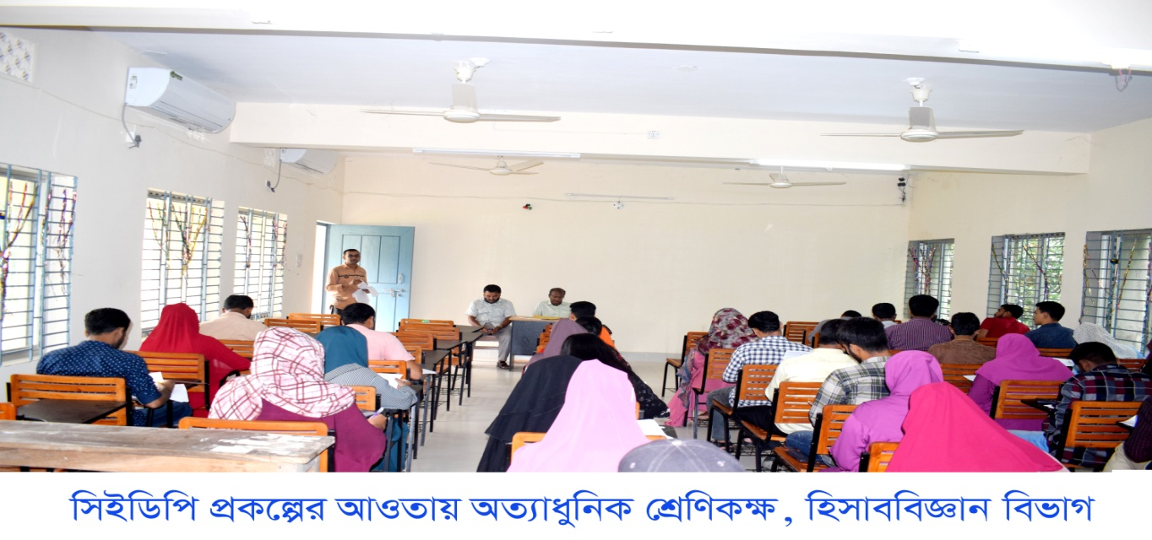

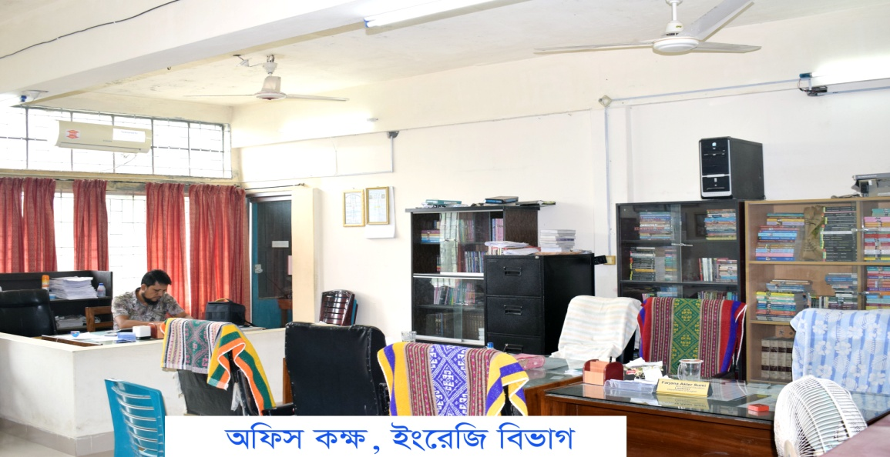

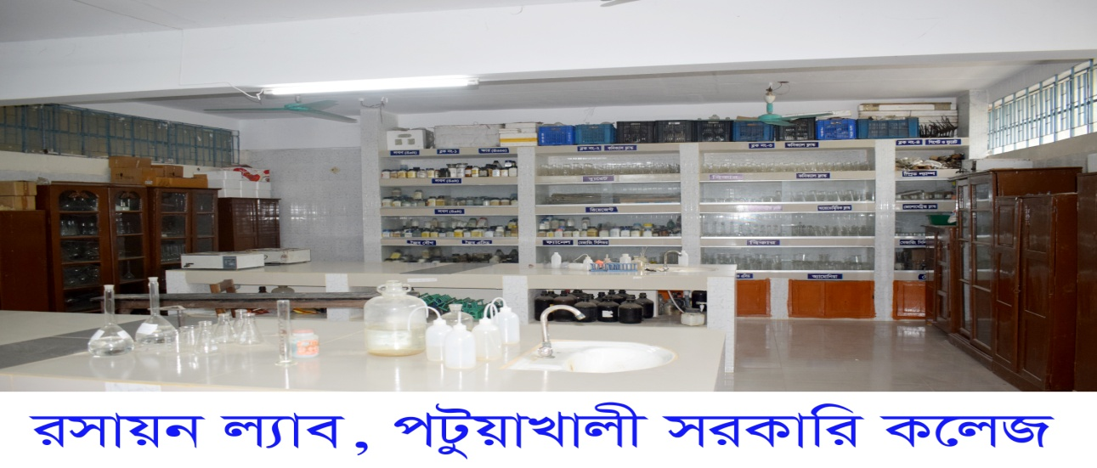

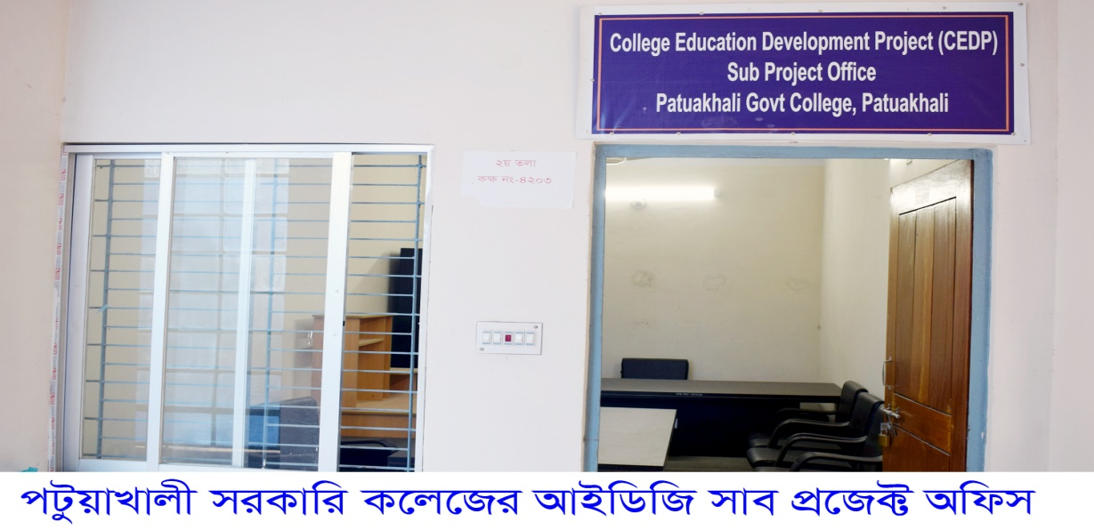

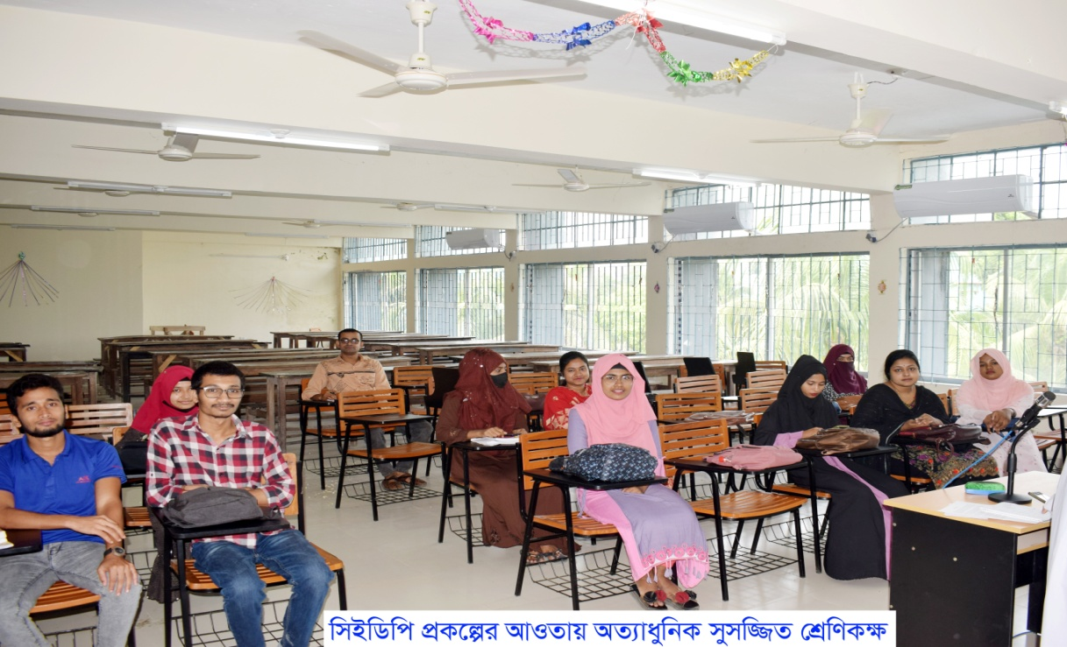

**(Professor Md. Nurul Amin)**

**ID No: 7050**

**Principal & IDG Manager**

**PatuakhaliGovt College, Patuakhali**